Appendix C: IEEE 830 Template
Software Requirements Specification
for
Library System
Version 1.2
Prepared by Seyithan Akdemir
03.11.26
«Page Break»

Table of Contents

Revision History
Name | Date | Reason for Changes | Version
Seyithan Akdemir | 03.11.26 | Creating the SRS | 1.0
Seyithan Akdemir | 03.25.26 | UML User Case Added | 1.1
Seyithan Akdemir | 03.29.26 | UML Class Added | 1.2
«Page Break»

1. Introduction
1.1. Purpose
Purpose of this document is to specify the requirements and preview some elements of the analysis model of the Library System
Library System is a simple program which consist of 4 programs:
LibraryServer
TestServer
BookMenu
StudyRooms
LibraryServer: Offers an easy way to use the database of quaries and answers. It unites other programs to use them as 1 program
TestServer: is used as client program. It loads a test file and uses random quaries selected by the program to test the Library Server
BookMenu:is used to sort the books and share status of the books(eg. missing, rented)\
StudyRooms:is used to inform user about status of study rooms or to rent the study rooms
1.2. Document Conventions
In general, this document prioritizes in writing the schema of the client-server mechanism that takes hold in this project and then analysing in details. Every requirement statement is assumed to have its own priority as to define in most appropriate way the system behaviour. In addition, there are various figures that represent the described system, where it is needed, and serve only for better understanding of the deployment.
1.3. Intended Audience and Reading Suggestions
This document is intended for any developer, tester, project manager that needs to understand the basic system architecture of this library system and its specifications.
Rest of the document contains architecture of this system and it’s features. How the system works, It’s Dependencies, Interfaces, Functional and Non-Functional Requirements.
1.4. Product Scope
The Library System is an integrated software system designed to automate operations of a Library System through a modular, client-server architecture with the objective of centralize all database queries to Library Server and benefits of Real-Time Transparency and Scalability and the goal of transforming the library from a simple storage facility into a dynamic, service-oriented hub.
«Provide a short description of the software being specified and its purpose, including relevant benefits, objectives, and goals. Relate the software to corporate goals or business strategies when applicable.»
1.5. References
2. Overall Description

2.1. Product Perspective
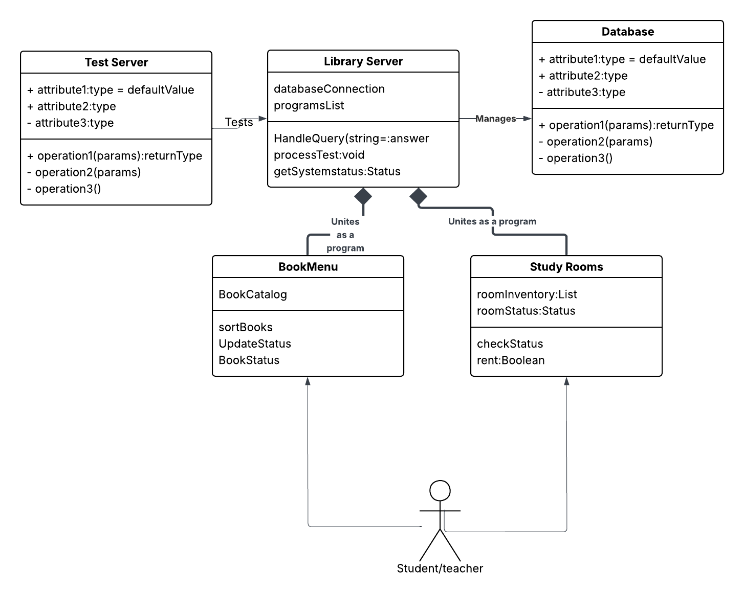
2.2. Product Features
2.3. User Classes and Characteristics
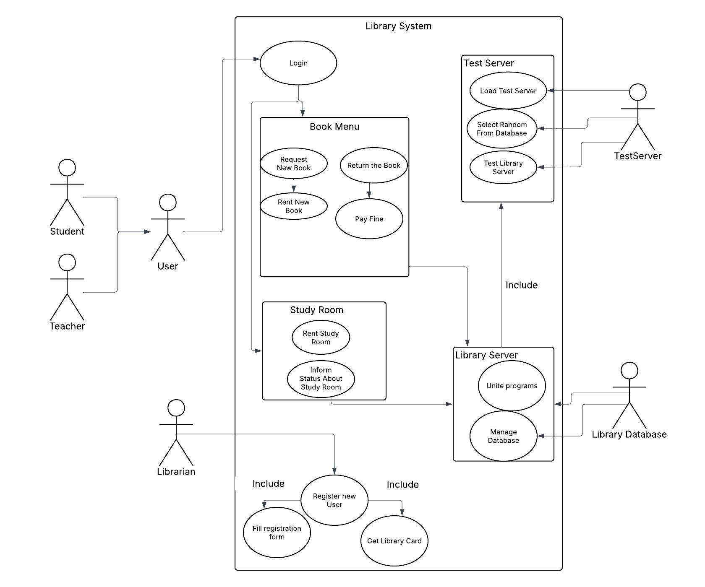
2.4. Operating Environment

2.5. Design and Implementation Constraints
2.6. User Documentation
2.7. Assumptions and Dependencies
3. System Features
3.1. Feature Name
3.«N». «Additional feature blocks as needed»
4. External Interface Requirements
4.1. User Interfaces Overview
4.2. Hardware Interfaces
4.3. Software Interfaces
5. System Features/Modules
5.1. «System Feature Name»
5.1.1 Description and Priority
5.1.2 Stimulus/Response Sequences
«”Stimulus” or “Condition”»: «Describe the stimulus or condition»
Response: «Describe the response»

5.1.3 Functional Requirements
REQ-1.1: The system shall allow users to create an account using email.
REQ-1.2: The system shall allow librarians to manage existing member profiles.
REQ-1.3: The system shall allow a registered library member to check out a physical copy of a book.
REQ-1.4: The system shall provide a search interface for users to locate items in the library's collection.
REQ-1.5: The system shall automatically calculate fines for overdue items.

5.«N». «Additional feature blocks»
6. Nonfunctional Requirements
6.1. Performance
NF-1.1: The system shall support at least 500 concurrent users during peak hours.
NF-1.2: The system shall respond to queries in < 2 seconds
6.2. Security
NF-2.1: The system shall have an uptime of 99.5% during operating hours and must ensure transactional integrity
6.«N». «Any additional “nonfunctional” blocks»

